# **Template –****Popup, Expand/Collapse Panel & GoogleMap Components**

The template named “Template – Popup, Expand/Collapse Panel & GoogleMap Components” is applicable to CampusNexus Student.

## Purpose and Outcome

This template provides an anonymous form sequence and supporting workflow for the use of Popup, Expand/Collapse Panel & GoogleMap components in a form.

## Prerequisites

The template was built with Forms Builder using the applications listed below. The template is forward compatible with later versions of the listed applications.

|  |  |
| --- | --- |
| **Application** | **Minimum Version** |
| Forms Builder Designer and Renderer | 3.7 |
| Web Client for CampusNexus Student | 21.1 |
| Workflow Composer | 3.0.x |
| Packages installed from Package Manager in Workflow Composer | Activities and Contracts (V1) 21.1.0  Activities and Contracts (V2) 21.1.0  Forms Builder Contracts 3.6.x |
| Workflow Tracking Database | N/A |
| Staff STS 2.1 | 2.1 |

## Prerequisites for Use of the Google Maps

Google Maps require a valid API key that must be configured in the Forms Builder Settings.

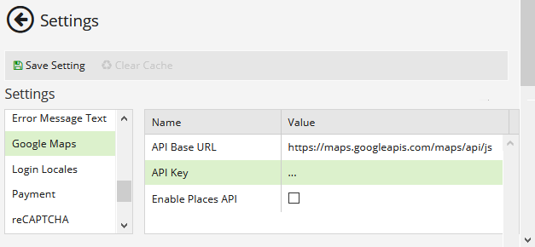

In addition, fees may apply depending on the usage of Google Maps in a production environment.   
For details, see <https://cloud.google.com/maps-platform/pricing>.

## Step 1: Download and Import the Template

1. Download the template file to your environment (local drive or network location).
2. Log into **Forms Builder** and select the **Export/Import** tile.
3. Select the **Import** tab.
4. Click **Select exported file** and navigate to the downloaded template file (xml).
5. Click **Import**.

* [Export/Import](https://help.campusmanagement.com/FB/3.x/Content/ExportImport.htm)

### The “GoogleMaps Example” and “Default-Confirmation” forms will be imported.

## Step 3: In Form Designer…

1. From the **Forms** slide out, select the **GoogleMaps Example** form.
2. Customize the form for your environment. Modify properties on fields/components to make them required, etc., or add/remove fields on the form.

* [Fields](https://help.campusmanagement.com/FB/3.x/Content/Fields.htm) and [Components](https://help.campusmanagement.com/FB/3.x/Content/Components.htm)

1. **Save** the form.

## Step 4: In Sequence Designer…

1. Locate the **GoogleMaps Example** sequence in the Sequences pane.
2. Click **Save As** to create a copy of the sequence/workflow and customize the copy for your use. This way you can always refer to the original sequence/workflow you downloaded.
3. (Optional) Customize the sequence properties for your environment.
4. (Optional) Add a custom style (theme) for your campus.

* [Themes](https://help.campusmanagement.com/FB/3.x/Content/Themes.htm)

1. Select your saved sequence in the Sequences pane.
2. In the Properties Pane, as **End State Form**, select the imported “Default-Confirmation”.
3. **Save** the sequence**.**

## Step 5: In Workflow Composer…

You do not need to modify anything in the workflow.

1. (Optional) Open the workflow for your saved sequence.

* [Opening Workflows for Sequences](https://help.campusmanagement.com/FB/3.x/Content/HostedEnv.htm)

1. (Optional) Explore the workflow to get an understanding of the workflow logic.

* [State Machine Workflows](https://help.campusmanagement.com/FB/3.x/Content/StateMachineWorkflows.htm)

## Step 6: In Forms Renderer…

Select your sequence and try it out!

* [Sequence List](https://help.campusmanagement.com/FB/3.x/Content/SequenceList.htm)

1. Find your sequenceand copy the **URL** to the clipboard.
2. Paste the URL into a browser and complete the form sequence.

## Step 6: Lastly…

Once your updated sequence has been tested successfully, it is recommended that you disable the workflow for the original Template version.

1. In Workflow Composer, in the Server section of the ribbon, click **Open**.
2. Find the workflow named **GoogleMaps Example**.
3. Clear the **Enabled** check box and click **Save**.